Removing Cubes
The pictures below show two solids made out of smaller cubes:
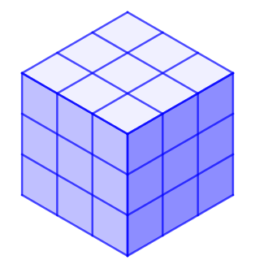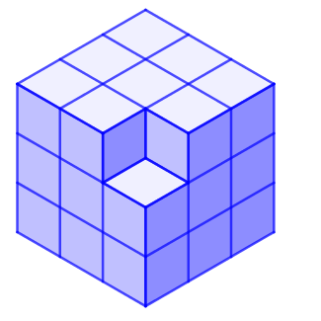

The first solid has a volume of 27cm³, and the second solid has a volume of 26cm³.
Work out the surface area of each solid. What do you notice?
Start with a 3 by 3 by 3 cube, and remove some cubes. Can you create solids with the same surface area as the original cube, with a volume of 25cm³? or 24cm³? … or 20cm³? or…
What is the minimum possible volume of a solid made in this way?

Removing Cubes
Teachers’ Resources
Why do this problem?
This problem offers students the opportunity to reason spatially in three dimensions, while consolidating their understanding of volume and surface area.
Possible approach
Students may need cubes and isometric paper.
Show students the two solids and invite them to work out the surface area of each.
Are they surprised that two solids with different volumes have the same surface area?
Set students the challenge to find more solids with the same surface area, made by removing cubes from a 3 by 3 by 3 cube.
Once they’ve found some examples, invite them to share strategies. Students might notice that removing cubes with three faces showing does not change the surface area.
Set them the challenge to find the minimum possible volume of a solid made in this way.
Finish off by discussing students’ insights and discoveries. Students may discover that the maximum surface area for any given volume is created by “snakes” where each cube (apart from the ends) is only attached to two others. This insight can lead them to the realisation that it is possible to remove more than half the cubes!
Key questions
If I remove a corner from a 3 by 3 by 3 cube what happens to the surface area?
When is it possible to remove a cube without changing the surface area?
Possible support
Make sure students have cubes available to test their ideas.
Possible extension
Students could explore the maximum possible surface area that can be achieved when removing cubes from a 3 by 3 by 3 cube.

